Tell it Right, Start it Right
Venue: Parent Craft Room, FPH, RHCH |  | Date: 25th November 2019 | Time: 9am-3.30pm
9.00 | Registration and coffee
9.20 | Welcome and scene setting
9.30 | About Down’s syndrome  - Exploring attitudes and the facts  - Living with Down’s syndrome in 2019
10.30 | Tea/Coffee break
10.45 | Tell it Right campaign  - What we hear from parents  - Screening and NIPT  - Supporting new families
12.00 | Lunch
12.45 | Parents’ perspective  - Sharing experiences  - Local group support and activities  - My life: a young person with Down’s syndrome (if young person is available)
14.00 | Tea/Coffee break
14.15 | Ensuring best practice  - Incorporating important points in practice: Case studies  - Review of current practice  - What parents want to know  - Information and resources  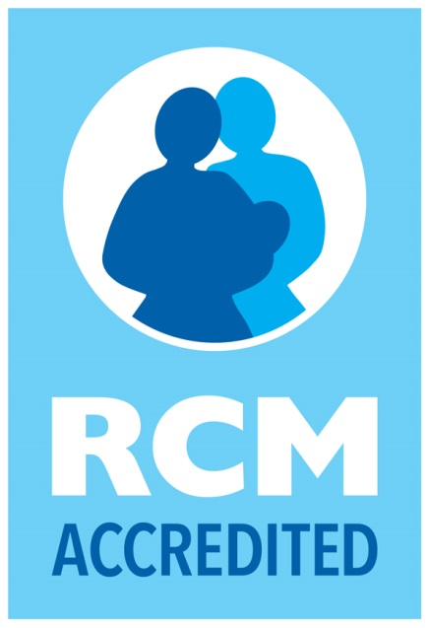
15.30 | Evaluation and close

www.downs-syndrome.org.uk

